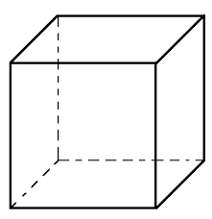

[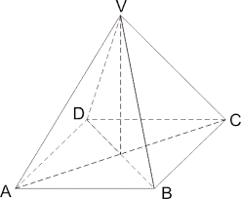](http://www.google.cz/url?sa=i&rct=j&q=&esrc=s&source=images&cd=&cad=rja&uact=8&ved=0CAcQjRw&url=http%3A%2F%2Fwww.vyukovematerialy.cz%2Fmatika%2F9%2Fjehlan%2Fuvod.htm&ei=CgjjVOSmJ9fZaoiFgpAF&bvm=bv.85970519,d.d2s&psig=AFQjCNGy4p-6uZ2FhVsq4DhrDGGHBjgo-A&ust=1424251249380877)